**Course: IC3234– Building and Process Automation Lab- 5**

**Class: T.Y.C. B. Tech (Instrumentation and Control Engineering)**

**Academic year 2021 – 22**

**Name: Shaunak Deshpande**

**Div.: TY-IC-C**

**Roll. No.: 39**

**GR no.: 11911180**

**Batch.: 2**

**LAB 5: Valve Position Control**

### Title: Valve Position Control

The exercise for the valve position workshop is based on a simple process example where a small valve and a large valve may be used to adjust the total flow to the process. The process is shown below.

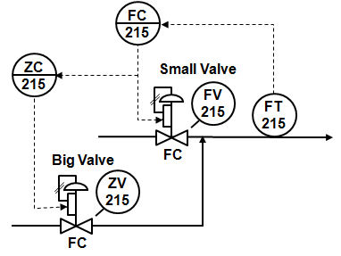

Step 1. In the valve position control workspace, change the mode of the flow controller to Auto.

Step 2. Change the flow controller SP (Setpoint) over the following range: 40, 50, and 60. Observe the change in the two outputs. Why is the small valve maintained at 50%?

Step 3. Change the SP of the valve position controller and observe the response.

**Workspace:**

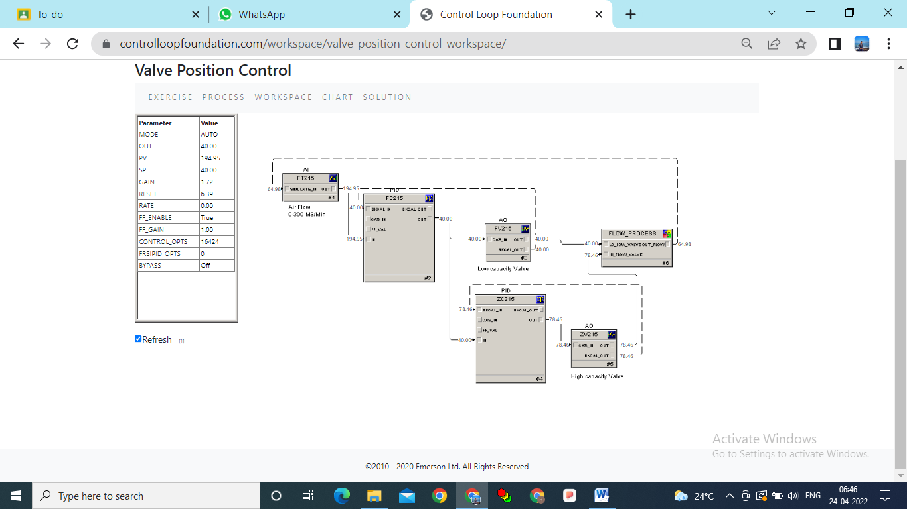

Setpoint range is 40

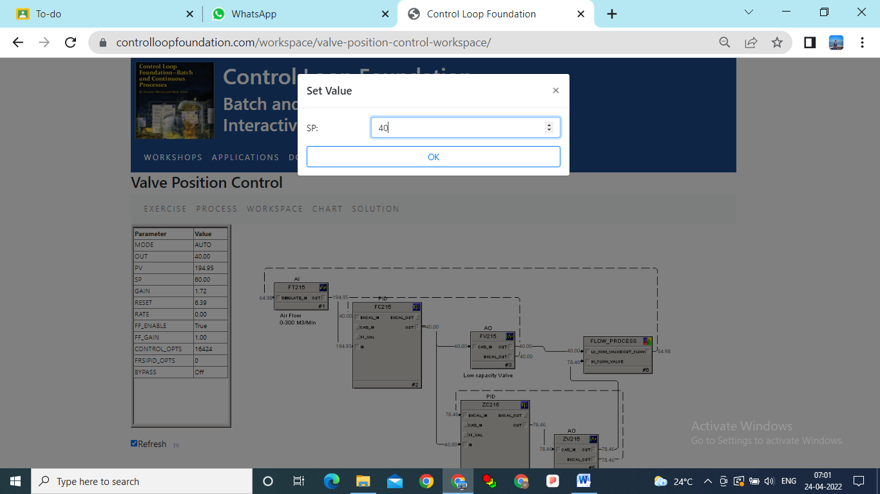

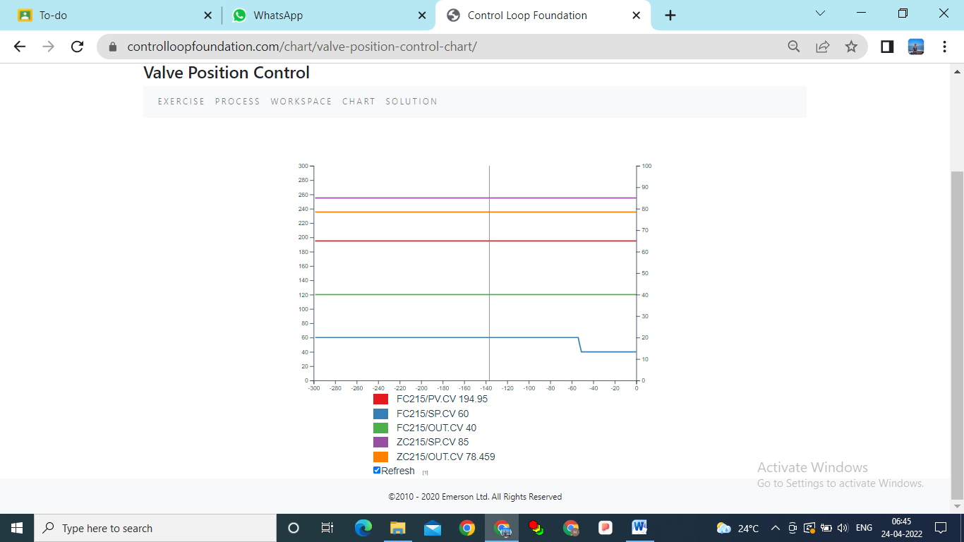

Setpoint range is 50

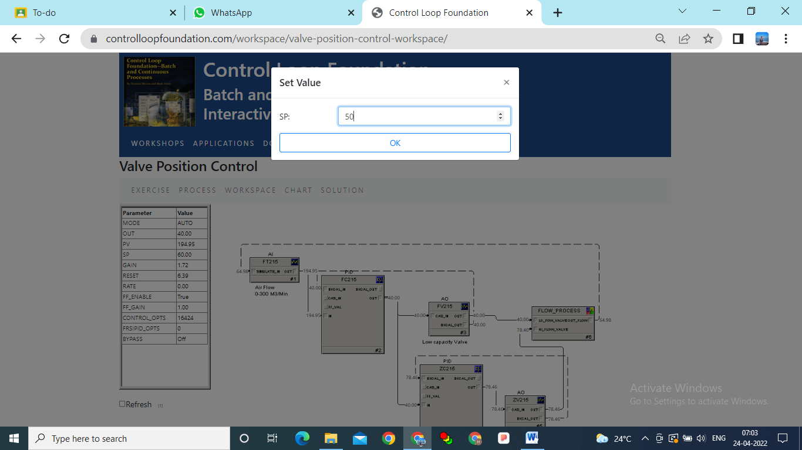

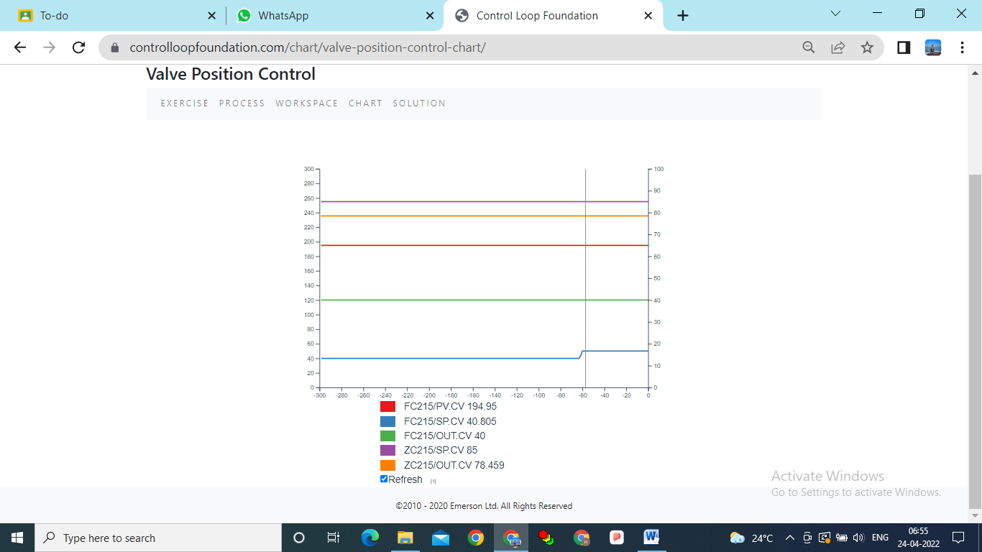

Setpoint range is 60

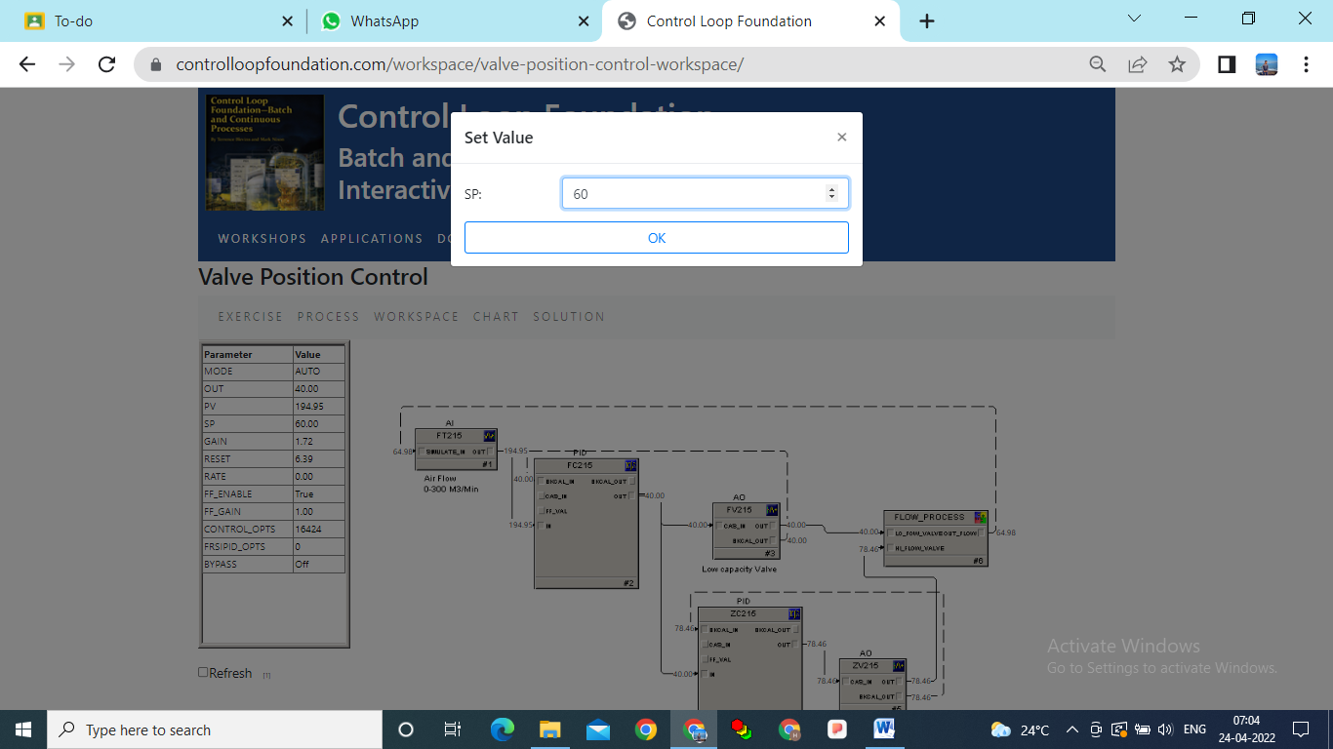

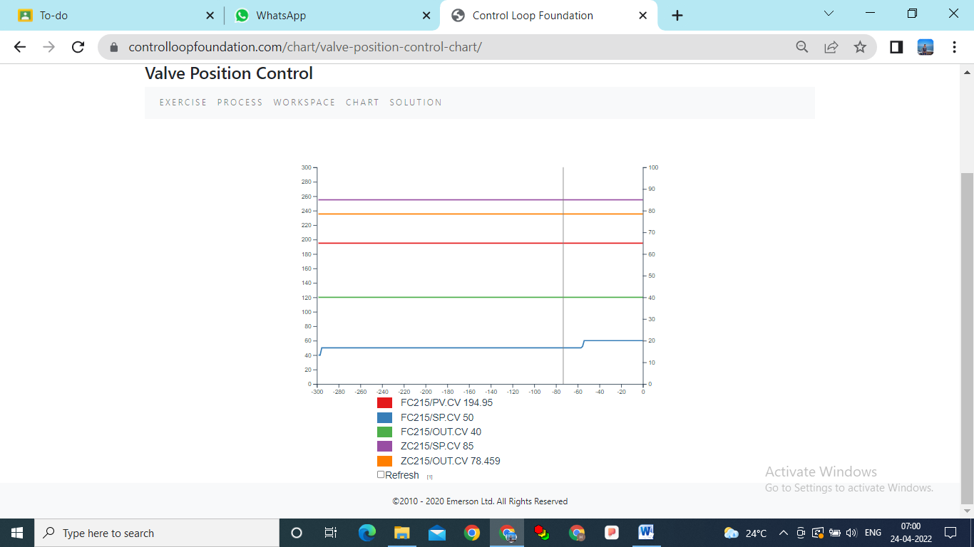

Why is the small valve maintained at 50%?

The increase in volumetric flowrate through this type of control valve increases by an equal percentage per equal increment of valve movement.

**Conclusion:**

In this Lab experiment we understand a designed to allow the operation of valve position control to be explored. This Lab is based on flow control using a small valve and a large valve.